Investigating Predictive vs. Random Task-Switching Using the CVOE Task

Nicholas P. Maxwell1, Jacob Namias1, & Mark J. Huﬀ1

* The University of Southern Mississippi

Author Note

Correspondence concerning this article should be addressed to Mark J. Huff, 118 College Dr, Hattiesburg, MS, 39406. E-mail: [mark.huff@usm.edu](mailto:nicholas.maxwell@usm.edu). [OSF NOTE HERE]

Abstract

Abstract will go here. . .

*Keywords:* Task-Switching; CVOE; Attentional Control; Working Memory

Investigating Predictive vs. Random Task-Switching Using the CVOE Task

The ability to only attend to relevant information within one’s environment is a key aspect of goal-directed behavior. Attentional control systems play a critical role in this process, as individuals with strong attentional control are more likely to ignore highly salient but unrelated information from their environment that would otherwise produce distractions. Researchers have commonly investigated attentional control using paradigms which present participants with task-related information that is contrasted with other information that is highly salient but task unrelated (see Rogers & Monsell, 1995 for review). These studies have consistently shown that when participants are required to actively suppress task-unrelated information, both response times (RTs) and error rates are increased (e.g., Jersild, 1927; CITE, CITE, etc.). Thus, taxing attentional control systems leads to declines on task performance.

Researchers have long been interested in the effects of attentional control on task performance. One of the earliest examples was reported in Stroop’s (1935) seminal color naming study. Stroop had participants read lists of color words, which were printed using ink that was either congruent or incongruent with the word’s meaning (i.e., “Blue” printed in blue ink vs. black ink). Participants were instructed to quickly name the color ink in which the word was printed, rather than reading the word. As a result, successfully completing the Stroop Color-Naming Task required participants to suppress the highly salient but task-irrelevant lexical information contained in the word. Overall, Stroop showed that both RTs and error rates were increased for color words presented in an incongruent ink (e.g., “Blue” presented in green ink) compared to when congruent ink was used (e.g., “Blue” presented in blue ink). Research in the following decades has found that decreases in performance that are observed for incongruent trials are further exaggerated whenever an incongruent trial immediately follows a congruent trial (i.e., congruency sequence effect, CSE; Aschenbrenner & Balota, 2019, Egner, 2007). Thus, participants are generally slower to respond and less accurate in their responding whenever they must suppress task irrelevant information to successfully complete a task. Further, these deficiencies are magnified whenever participants must switch between multiple trial types.

The Stroop Color-Naming Task has received significant attention in the literature and has subsequently been described as “the gold standard” of attentional control (see MacLeod, 1992). This is because to complete the task, individuals must successfully activate and maintain the task goal of naming the ink color while suppressing highly salient but task irrelevant information (reading the word). As a result, researchers interested in the effects of both healthy and unhealthy aging on attentional control processes have commonly used variations of the Stroop task as a means for assessing declines in attentional process that occur as a function of aging. For example, Spieler, Balota, & Faust (1996) showed that overall performance on the Stroop task decreased as a function of both healthy aging and Alzheimer’s Disease (AD) diagnosis. Specifically, compared to younger adults, healthy older adults showed slower RTs (but not an increase in error rates). For AD individuals, however, large costs to both RTs and error rates were observed, even when these individuals were matched to healthy older adults of the same age. More recently, Hutchison, Balota, & Ducheck (2010) showed that the Stroop Color-Naming Task could be used to discriminate healthy aging from AD, suggesting that this task is sensitive to the breakdowns in attentional control that inherent to AD. It is evident, therefore, that attentional control is critical for keeping internal goals active, as participants with impaired attentional control systems experience greater difficulty staying on task when required to surpass task-irrelevant information.

While researchers have commonly used the Stroop task as a measure of attentional control, there has been an increased focus on using task-switching paradigms as an additional technique to investigate questions related to attentional control processes. In a standard task-switching paradigm, participants alternate between completing a pair of contrasting tasks (e.g., Jersild, 1927; Rogers & Monsell, 1995). These paradigms typically present participants with at least two types of experimental conditions. First, participants complete *pure blocks* which focus exclusively on one task (i.e., participants only complete addition problems). Participants then complete *switch blocks* in which they quickly alternate between two contrasting tasks (i.e., addition on trial one but subtraction on trial two). Like the Stroop Color-Naming Task, switch blocks require participants to attend to a relevant task-set (i.e., the current task instructions) while suppressing irrelevant but salient information from the inactive task-set. To assess differences in attentional control, response times (RTs) and error rates are compared between the two block types. Overall, studies investigating task-switching have repeatedly shown that participants commit more errors and have slower RTs for switch trials compared to non-switch trials, and, like the Stroop task, declines in attentional control can exaggerate these costs (e.g., Huff, Balota, Minear, Aschenbreener, & Duchek, 2015).

Although researchers have developed a variety of tasks to investigate task-switching effects, the present study focuses specifically on task-switching paradigms in which a direct comparison can be made between local and global switch costs (e.g., Huff et al. 2015; Mayr, 2001; Minear & Shah, 2008; etc.). These paradigms initially present participants with a set of pure blocks (one corresponding to each task-set). These pure blocks are then immediately followed by one or more switch blocks in which participant complete a series of interleaved switch and non-switch trials (e.g., switch, non-switch, switch, non-switch, etc.). The *global switch cost* refers to the difference between switch trials and pure block trials and represents the cost of maintaining multiple task configurations in a switch block compared to a single task configuration within the pure block (Minear & Shah, 2008; Wylie & Allport, 2000). Alternatively, the *local switch cost* is found by computing the difference between switch and non-switch trials presented within the same switch block. Local costs represent task-set reconfiguration processes that occur due to participants changing tasks-sets within the same block of trials (Rogers & Monsell, 1995; see Huff, et al., 2015).

While declines in attentional control due to aging have been shown to influence performance on switch tasks (see Huff et al., 2015), the stimuli used have also been shown to influence both accuracy and RTs. For example, previous research has shown that switch costs are particularly magnified whenever the stimuli do not clearly signal to participants which of the two tasks is to be performed (Luwel, Schillemans, Ongehan, & Vershaffel; 2009). Termed *bivalent* stimuli, these items activate both task-sets used in a switch task (i.e., presenting participants with letter-number pairs and having them switch between classifying the letter or the number). Compared to *univalent* stimuli which only correspond to one task-set (i.e., presenting participants with only letters or numbers), responses are often slowed, as participants must consider both task sets (e.g., bivalency cost; Woodward; Meier, Tipper, & Graf; 2003). Because bivalent stimuli are more challenging for participants, researchers have often commonly incorporated them when developing task switching paradigms. One example is the Consonant-Vowel Odd-Even switch-task (CVOE; Minear & Shah, 2008), which is a classification task that presents participants with letter-number pairs (e.g., A 15). Depending on the task-set being cued, participants are instructed to either classify the letter in the pair as being a consonant/vowel or the number as being odd/even. Because this task presents participants with a set of pure blocks before the switch block, the CVOE task therefore allows for measurement of both local and global switch costs.

Within the past decade, researchers have made extensive use of the CVOE task to investigate questions related to attentional control. Often, studies using the CVOE task have been interested in the effects of healthy and unhealthy aging on attentional control. For example, Tse, Balota, Yap, Duchek, & McCabe (2010) compared performance between young, healthy older adults, and older adults with mild cognitive impairments (MCI) on three attentional control measures including the CVOE task. Though Tse et al. were primarily interested in distributional measures of RTs as a measure of attentional control processes (rather than traditional analyses of mean RTs and Error rates), we note that MCI individuals showed greater local switch costs for errors relative to younger adults. For RTs, MCI individuals showed decreased local costs compared to healthy older adults. Tse et al. attributed the increased cost to errors and the subsequent decrease in local costs to RTs as being due to MCI individuals having greater difficulty suppressing the inactive task set when switching.

More recently, Huff et al. (2015) compared CVOE task-switching between young adults, healthy middle aged and older adults, and MCI older adults. Overall, MCI older adults committed more errors and had slower RTs relative to both young adults and healthy older adults, with task performance particularly affected for switch trials compared non-switch trials in which the task-set does not change. Importantly, Huff et al. (2015) compared changes in global and local costs of both errors and RTs as a function of age and MCI status. First, global switch costs (switch trials compared to pure trials) for errors increased as a function of both age and MCI status. This pattern subsequently extended to global costs of RTs, suggesting that requirement to keep two task sets active placed additional burdens on working memory. For local costs, however, no group differences in errors emerged, but local costs of RTs decreased across groups, suggesting that MCI individuals were not as well tuned to the task set relative to younger adults and healthy older adults.

**Predictive vs. Random Switching**

In addition to the type of stimuli used (e.g., bivalent vs. univalent), task-switching paradigms can be further classified based on the timing in which switches occur. First, switches can occur in a predictable sequence, such as an *alternating runs* presentation sequence (e.g., Rogers & Monsell, 1995; Huff et al., 2015). In an alternating runs switch task, task changes occur as a function of run length (*r*). Thus, switches occur in *r* trial intervals (e.g., AABBAABB for *r* = 2). Because of the predictive nature of this sequence, participants are generally aware of when task-switches will occur. Alternatively, task switches may occur at unpredictable intervals. Unlike when switching is predictable, in a random switch paradigm, the upcoming task is unknown to participants until they are cued to change tasks. Random task switching can be further divided based on when participants receive change cues. In task-cueing paradigms (e.g., Meiran, 1996), participants receive cues at each trial, while intermittent instruction paradigms (e.g., Gopher, Armony, & Greenshpan, 2000) randomly interrupt task sequences with instructions to change (see Monsell, Sumner, Waters, 2003 for a review of predictable vs. random task-switching paradigms).

Previous research has investigated the effects of predictive vs. random switching on RTs and error rates. For example, in their second experiment, Monsell et al. (2003) compared performance on a four-run alternating switch task to a random task-cueing switch paradigm. Overall, Monsell et al. showed that random switching was more difficult for participants than predictive switching, as participants in the random group took more trials to recover from a switch (i.e., change task-sets) compared to when switching was predictive. We note, however, that the switch task used by Monsell et al. did not allow for a comparison of local and global switch costs. More recently, Minear & Shah (2008) had participants complete both predictive and random switching within the CVOE task. However, because the primary focus of their study was on transfer effects, direct comparisons between switch presentation were not reported. Thus, it remains unclear how switch presentation would affect both task performance (i.e., errors rates and RTs) and switch costs.

**Distributional Analyses of RTs**

Task-switching paradigms commonly use error rates and RTs as indicators of performance. Commonly, researchers assess changes in performance in terms of mean or median scores. However, because RT distributions are almost always positively skewed (i.e., most RTs generally occurring at the faster end of the scale), performing an analysis of only mean RTs may produce results that are misleading (see Balota & Yap, 2011 for a review). To account for this, researchers have increasingly moved away from using traditional measures of central tendency as their primary mode of analyses when assessing RTs and, instead, have moved towards analyses of RT distributions. Previous research has shown that the characteristics of these distributions can successfully capture important aspects of human cognition, including word recognition (e.g., Andrews & Heathcote, 2001; Balota & Spieler, 1999), semantic priming (e.g., Balota, Yap, Cortese, & Watson, 2008), selective attention (Lamers, Roelofs, & Rabeling-Keus, 2010; Spieler, Balota, & Faust, 2000), and, importantly, attentional control (Huff et al., 2015; Tse et al., 2010).

Given the increased focus on RT distributions, in the present study, we further analyzed RT data using two types of distributional analyses: Vincentile analyses and ex-Gaussian analyses. First, the Vincentile analysis rank orders all RTs for each trial type at the participant level and then bins the ordered data into groups of equal size. For example, a Vincentile analyses using four bins would first each participant’s RTs from fastest to slowest. Next, for each participant, RTs within the first 25% of the data would be averaged, followed by the second 25%, third the 25%, and the final 25%. This process is then repeated for each participant, and Vincentiles are computed by taking the average of each bin across participants. As a result, Vincenetile analyses reflect the average shape of the RT distribution. Regarding the ex-Gaussian analysis, participants’ raw RT scores are fit to a theoretical ex-Gaussian distribution, which provides a close approximation of the empirical RT distribution (Ratcliff, 1979). Three parameters define this distribution. First, the Mu and Sigma parameters represent the mean and standard deviation, respectively. The third parameter, Tau, represents the tail of the distribution. Thus, changes in Mu reflect a shift in the overall RT distribution, while changes in Tau represent changes to the tail. Regarding attentional control tasks, individuals with impaired attentional control systems would be less likely to consistently maintain the task goal while suppressing irrelevant information, leading to slower RTs and more errors when compared to individuals with whose attentional control systems are more intact. This would result in RT distributions with a larger tail and thus a larger Tau. Furthermore, when task-switching, Tau would be expected to increase whenever the switch task places additional strain on attentional control systems (e.g., predictive vs. random task-switching).

Finally, as noted by Tse et al. (2010), conditions producing the same mean RTs could potentially have different underlying RT distributions. Thus, distributional analyses provide a more fine-grained analysis relative to relying on only means (see Balota et al., 2008). Given the benefits of using these analyses when used to investigate attentional control processes, the present study incorporates these distributional analyses in addition to traditional mean analyses.

**The Present Study**

The goal of the present study was to expand previous research on CVOE task-switching by comparing error rates and RTs for predictive (e.g., alternating runs; CV-CV-OE-OE-CV-CV) and random switching (e.g., CV-OE-OE-OE-CV-OE). Overall, we expected that mean error rates and RTs would be higher on switch blocks (regardless of presentation sequence) relative to pure blocks, given that pure blocks only require participants to engage in a single task-set. However, within switch blocks, we expected that participants would particularly struggle whenever switching occurred at non-predictive intervals due to the lack of a discernable pattern. Given the increased difficulty of random switching, we anticipated that participants would produce more errors and have slower RTs when switching was random compared predictive, alternating runs switching. Furthermore, we expected that the increased difficulty of the random switch task should lead to inflated switch costs relative to predictive switching.

**Method**

**Participants**

A total of 100 undergraduate students were recruited from the University of Southern Mississippi’s undergraduate research pool and completed the study in exchange for partial course credit. Data from 9 participants were removed due to excessive error rates in either the pure or switch blocks (i.e., mean error rates within a block that were > 3 standard deviations above the mean), which indicated that participants did not correctly follow task instructions. Additionally, data for two participants were removed due to a coding error. A sensitivity analysis conducted with *G*Power* (Faul, Erdfelder, Lang, & Buchner, 2007) indicated that our final sample of 89 participants was sufficient to detect a small effect (*d* ≥ 0.20). All participants were native English speakers who reported normal or corrected to normal vision.

**Materials**

To create the stimuli, we generated a series of letter-number stimulus pairs (e.g., A 15) using the following process. First, an even number of consonants and vowels were created. These letters were always selected from A, D, E, H, I, J, O, P, S, or U. Next, a series of numbers were randomly selected between 1 and 99, with the constraint that half of the numbers selected were always even. To create the pairs, half of the consonants were paired with an odd number, while the remaining half were paired with even numbers. This process was then repeated for vowels. This resulted in an equal number of each of the four possible stimulus pair types (Consonant-Odd, Consonant-Even, Vowel-Odd, Vowel-Even) within each block. Letters and numbers repeated within blocks, however, pairs were arranged within each block such that repeats did not occur on consecutive trials.

**Procedure**

The CVOE task presented participants with two sets of instructions, which either differed between blocks (pure blocks) or as a function of trial (switch blocks). For each trial, a letter-number pair was presented in the center of the computer screen, and participants were tasked with classifying whether the letter was a consonant/vowel (CV trials) or an odd/even number (OE trials). Depending on the type of trial, the words consonant/vowel or odd/even were presented at the top of the screen in the left and right corners to serve as a reminder. Participants were instructed to press the *q* key for consonants/odd numbers or the *p* key for vowels/even numbers. These keys were selected given that they are on opposites sides of a standard QWERTY keyboard. Stimuli were presented in 30-point Courier New font, and trials were presented with a 500 ms intertrial delay.

Trials were arranged into four blocks, with each block containing an equal distribution of *q* and *p* responses. Following the design of Huff et al. (2015), participants first completed two pure blocks (CV and OE) before completing two switch blocks (alternating runs and random presentation). Participants initially completed a set of 10 practice trials which corresponded to the first pure block’s task (CV or OE) and received verbal feedback on their performance. Following completion of the practice phase, participants immediately began the first pure block. Pure blocks each contained 96 trials and focused exclusively on one of the two tasks, with one block containing the CV task and the other the OE task. Following completion of the first pure block, participants completed a second set of practice trials (corresponding to the task in the second pure block) before completing the second pure block.

Immediately following completion of the two pure blocks, participants began the two switch blocks. In the switch blocks, the task change occurred at the trial level rather than the block level. For each trial, participants were prompted with the word “letter” or “number”, which corresponded to the CV or OE task, respectively. This prompt was located above the stimulus pair, and participants were informed that the prompt could potentially change following each key press. To practice the switching task and become familiar with the prompts, participants first completed a set of ten practice switch trials. Following this practice session, participants immediately began the first switch block. Trials within the switch blocks were arranged such that they were presented either with an alternating runs pattern (e.g., CV, CV, OE, OE, CV, CV, etc.; see Huff et al., 2015) or presented using a random presentation sequence (e.g., CV, OE, OE, OE, CV, OE, etc.). Each switch block consisted of 120 trials, which consisted of 59 switch trials (i.e., a CV trial followed by an OE trial) and 61 nonswitch trials (i.e., two consecutive OE trials). Like the pure blocks, each switch block corresponded to one of these two presentation modes (alternating runs or random). Thus, participants completed one pure CV block, one pure OE block, one alternating run switch block, and one random presentation switch block. Block presentation was randomized across participants; however, blocks were always ordered such that participants completed the two pure blocks before completing the two switch blocks (Huff et al., 2015; Minear & Shah, 2008).

Across blocks, participants were instructed to respond to each trial as quickly as possible without compromising accuracy. The task was presented to participants on a laptop running E-Prime 3.0 software (Psychology Software Tools, Pittsburgh, PA), and all participants were tested individually in a laboratory setting. The total experiment took approximately 20 minutes to complete.

**Results**

For all analyses, significance was set at the *p* < .05 level. Generalized-eta squared (*η*2G) and Cohen’s *d* effect size estimates were computed for all significant analyses of variance (ANOVAs) and *t*-tests, respectively. In addition to reporting effect size indices, all standard null-hypothesis testing was supplemented with a Bayesian estimation of the strength of evidence in favor of the null hypothesis, which compares a model that assumes a significant effect to one that assumes a null effect (Masson, 2011; Wagenmakers, 2007). This analysis returns a probability estimate termed *p*BIC (Bayesian Information Criterion) which represents the likelihood that the null hypothesis is retained. Therefore, all null effects include a *p*BIC estimate.

In the following analyses, we first examine mean error rates across trial types (pure, alternating switch, alternating nonswitch, random switch, and random nonswitch) and switch costs (local vs global). We then assess changes in mean RTs across trial types and switch costs. Following the design of Huff et al. (2015), all RT analyses only included correct trials. Additionally, pre-analysis trimming procedure was used to reduce the likelihood of RT analyses being disproportionately influenced by extreme scores. We defined RT outliers as any responses occurring three standard deviations above or below of each participant’s respective mean. This process removed < 2% of all total trials. Next, mean Vincentiles were plotted for each trial type to produce the RT distribution profile. Finally, RTs were fit to an ex-gaussian distribution to assess parameter changes as a function of trial type.

**Mean Error Rates**

Mean error rates as a function of trial type are reported in Table 1. Overall, participants committed the most errors on alternating runs switch trials (6.12%), followed by random switch trials (5.17%), alternating runs non-switch trials (3.49%), pure trials (3.25%), and random non-switch trials (3.01%). A one-way repeated measures ANOVA confirmed that error rates differed as a function of trial type, *F*(4, 352) = 20.29, *MSE* = 8.16, *η*2G = .09. Post-hoc *t*-tests, revealed that this effect was driven by increased errors for switch trials relative to nonswitch and pure trials, *t*s ≥ 3.63, *d*s ≥ 0.43. For switch trials, mean error rates were marginally greater when trials were presented using alternating runs compared to random presentation, *t*(88) = 1.92, *SEM* = 0.50, *p* = .06, *d* = 0.21, *p*BIC = .60. However, no differences were detected between pure and nonswitch trials, regardless of switch trial presentation pattern, *t*s < 1, *p*s ≥ .48, *p*BICs ≥ .88.

Next, we compared differences in switch costs for errors as a function of presentation and cost type (Table 2). A 2 (Switch Cost: Local vs. Global) × 2 (Presentation: Alternating Runs vs. Random) repeated measures ANOVA yielded a significant main effect of Switch Cost, *F*(1, 88) = 26.83, *MSE* = 19.03, *η*2G = .10, such that collapsed across presentation modes, local switch costs exceeded global costs (2.39 vs. -0.003). Additionally, this analysis revealed a marginal effect of Presentation, *F*(1, 88) = 3.68, *MSE* = 5.43, *p* = .06, *p*BIC = .60, *η*2G = .01. Collapsed across cost types, switch costs were greater for alternating runs (1.43) compared to random switching (0.96). The interaction between Switch Cost and Presentation, however, was non-significant, *F*(1, 88) < 1, *MSE* = 17.35, *p* = .99, *p*BIC = .90.

**Mean RTs**

Next, we assessed changes in mean RTs across trial types. As reported in Table 1, mean RTs were fastest when participants responded to pure block trials (677.20 ms) followed by random non-switch trials (1259.87 ms), alternating runs non-switch trials (1328.27 ms), alternating runs switch trials (1414.49 ms), and random switch trials (1450.55 ms). A one-way repeated measures ANOVA confirmed the presence of trial type differences, *F*(4, 352) = 357.72, *MSE* = 19.03, *η*2G = .10. Post-hoc testing, however, indicated that for switch trials, RTs did not differ between predictive and random switching, *t*(88) = 1.69, *SEM* = 21.58, *p* = .09, *p*bic = .69. All other comparisons were significant, *t*s ≥ 3.56, *d*s ≥ 0.20.

Regarding switch costs for RTs, a 2 (Switch Cost: Local vs. Global) × 2 (Presentation: Alternating Runs vs. Random) repeated measures ANOVA yielded a significant effect of Switch Cost, such that global costs (616.87) were greater than local costs (138.45), *F*(1, 88) = 271.36, *MSE* = 75069.95, *η*2G = .56. The main effect of Presentation was non-significant, *F*(1, 88) = 2.87, *MSE* = 10075.84, p = .09, *p*bic = .69. The interaction, however, was significant, *F*(1, 88) = 26.87, *MSE* = 24744.18, *η*2G = .04. For local costs, the switch cost was greater when participants engaged in random switching relative to predictive switching (190.68 vs. 86.21, respectively; *t*(88) = 5.14, *SEM* = 19.50, *d* = 0.27). However, this pattern flipped for global costs, with predictive switching showing a higher global switch costs relative to random switching (651.07 vs. 582.67; *t*(88) = 3.56, *SEM* = 20.60, *d* = 0.64).

**Vincentile Plots**

Figure 1 reports Vincentile plots separated by trial type. The RTs used to construct these plots were the same as used in the mean RT analyses reported in the previous section. As illustrated in this plot, RTs increased across bins, regardless of trial type. Additionally, RTs were lowest for pure trials, followed by random non-switch trials, alternating runs non-switch trials, alternating runs switch trials, and random switch trials. These patterns were confirmed by significant effects of Bin, *F*(5, 440) = 370.58, *MSE* = 279313.51, *η*2G = .54, and Trial Type, *F*(4, 352) = 357.65, *MSE* = 154415.08, *η*2G = .33. Additionally, a significant interaction was detected, *F*(20, 1760) = 102.60, *MSE* = 14800.05, *η*2G = .06, indicating the increases in RTs across the distribution were steeper for switch and non-switch trials relative to pure trials.

Local and global switch costs for each Vincentile bin are displayed in Figure 2. Starting with local costs, switch costs were greater for random switching compared to alternating runs *F*(5, 440) = 370.58, *MSE* = 279313.51, *η*2G = .54. The Bin × Presentation interaction was significant, [stats], indicating that [EXPAND]. For global costs, switch costs increased across bins. Although switch costs did not differ as a function of presentation, [STATS], a significant Bin × Presentation interaction indicated that these increases were greater for alternating runs switching versus random switching, [STATS]. Taken together, local and global costs demonstrated a dissociation, such that local costs decreased or remained the same between the first and last bins, while global costs showed sharp increases.

**Ex-Gaussian Distribution of RTs**

[EX-GAUSS]

**General Discussion**

The goal of the present study was to assess the effects of switch trial presentation sequence on error rates and RTs. Overall, [SUMMARY PARAGRAPH – MAIN ANALYSES]

[SUMMARY PARAGRAPH – DISTRIBUTIONAL ANALYSES]

[SOMETHING HERE – I’LL FIGURE IT OUT LATER]

[AGING IMPLICATIONS]

[FUTURE DIRECTIONS]

**Summary and Conclusion**

[WORDS HERE]

**References**

Andrews, S., & Heathcote, A. (2001). Distinguishing common and task-specific processes in word identification: A matter of some moment? *Journal of Experimental Psychology: Learning, Memory, and Cognition, 27*(2), 514–544.

Aschenbrenner, A. J., & Balota, D. A. (2019). Additive effects of item-specific and congruency sequence effects in the vocal Stroop task. *Frontiers in Psychology, 10*, 860.

Balota, D. A., & Spieler, D. H. (1999). Word frequency, repetition, and lexicality effects in word recognition tasks: Beyond measures of central tendency. *Journal of Experimental Psychology: General, 128*(1), 32-55.

Balota, D. A., & Yap, M. J. (2011). Moving beyond the mean in studies of mental chronometry: The power of response time distributional analyses. *Current Directions in Psychological Science, 20*(3), 160-166.

Balota, D. A., Yap, M. J., Cortese, M. J., & Watson, J. M. (2008). Beyond mean response latency: Response time distributional analyses of semantic priming. *Journal of Memory and Language, 59*(4), 495-523.

Egner, T. (2007). Congruency sequence effects and cognitive control. *Cognitive, Affective, & Behavioral Neuroscience, 7*, 380-390.

Faul, F., Erdfelder, E., Lang, A. G., & Buchner, A. (2007). G*Power 3: a flexible statistical power analysis program for the social, behavioral, and biomedical sciences. *Behavior* *Research Methods*, *39* (2), 175–191.

Gopher, D., Armony, L., & Greenshpan, Y. (2000). Switching tasks and attention policies. *Journal of Experimental Psychology: General, 129*, 308-339.

Huff, M. J., Balota, D. A., Minear, M., Aschenbrenner, A. J., & Duchek, J. M. (2015). Dissociative global and local task-switching costs across younger adults, middle-aged adults, older adults, and very mild Alzheimer’s disease individuals. *Psychology and Aging, 30*(4), 727–739.

Hutchison, K. A., Balota, D. A., & Duchek, J. M. (2010). The utility of Stroop task switching as a marker for early-state Alzheimer’s disease. *Psychology and Aging, 25*(3), 545-559.

Jersild, A. T. (1927). Mental set and shift. *Archives of Psychology, Whole No. 89*.

Lamers, M. J. M., Roelofs, A., & Rabeling-Keus, I. M. (2010). Selective attention and response set in the Stroop task. *Memory & Cognition 38*, 893–904.

Luwel, K., Schillemans, V., Onghena, P., & Verschaffel, L. (2009). Does switching between strategies within the same task involve a cost? *British Journal of Psychology, 100*(4), 753-771.

MacLeod, C. M. (1992). The Stroop task: The “gold standard” of attentional measures. *Journal of Experimental Psychology: General, 121*(1), 12-14.

Masson, M. E. J. (2011). A tutorial on a practical Bayesian alternative to null-hypothesis significance testing. *Behavior Research Methods, 43*, 679-690.

Mayr, U. (2001). Age differences in the selection of mental sets: The role of inhibition, stimulus ambiguity, and response-set overlap. *Psychology and Aging, 16*, 96-109.

Meiran, N. (1996). Reconfiguration of processing mode prior to task performance. *Journal of Experimental Psychology: Learning, Memory, & Cognition, 22*, 1423-1442.

Minear, M. & Shah, P. (2008). Training and transfer effects in task switching. *Memory & Cognition, 36*, 1470-1483.

Monsell, S., Sumner, P., & Waters, H. (2003). Task-set reconfiguration with predictable and unpredictable task switches. *Memory & Cognition, 31*(3), 327-342.

Psychology Software Tools, Inc. [E-Prime 3.0]. (2016). Retrieved from https://www.pstnet.com.

Ratcliff, R. (1979). Groupreaction time distributions and an analysis of distribution statistics. *Psychological Bulletin, 86*(3), 446-461.

Rogers, R. D., & Monsell, S. (1995). Costs of predictable switch between simple cognitive tasks. *Journal of Experimental Psychology: General, 124*(2), 207-231.

Spieler, D. H., Bolota, D. A., & Faust, M. E. (2000). Levels of selective attention revelated through analyses of response time distributions. *Journal of Experimental Psychology: Human Perception and Performance, 26*(2), 506-526.

Spieler, D. H., Balota, D. A., & Faust, M. E. (1996). Stroop performance in healthy younger and older adults and in individuals with dementia of the Alzheimer's type. *Journal of Experimental Psychology: Human Perception and Performance, 22*(2), 461–479.

Stroop, J. R. (1935). Studies of interference in serial verbal reactions. *Journal of Experimental Psychology, 18*, 643-662.

Tse, C.-S., Balota, D. A., Yap, M. J., Duchek, J. M., & McCabe, D. P. (2010). Effects of healthy aging and early stage dementia of the Alzheimer's type on components of response time distributions in three attention tasks. *Neuropsychology, 24*(3), 300–315.

Wagenmakers, E. (2007). A practical solution to the pervasive problems of *p* values. *Psychonomic Bulletin & Review, 14*, 779-804.

Woodward, T. S., Meier, B., Tipper, C., & Graf, P. (2003). Bivalency is costly: Bivalent stimuli elicit cautious responding. Experimental *Psychology*, 50(4), 233–238.

Wylie, G., & Allport, A. (2000). Task switching and the measurement of “switch costs.” *Psychological Research, 63*, 212-233.

Table 1

*Mean Errors and RTs as a Function of Trial Type.*

|  |  |  |  |
| --- | --- | --- | --- |
| Measure | Trial Type | *M* | ± 95% *CI* |
| Error Rates | Pure | 3.25 | 0.59 |
|  | Alt. Runs Switch | 6.12 | 1.11 |
|  | Random Switch | 5.17 | 0.76 |
|  | Alt. Runs Non-Switch | 3.49 | 0.83 |
|  | Random Non-Switch | 3.01 | 0.67 |
| RTs | Pure | 677.20 | 33.14 |
|  | Alt. Runs Switch | 1414.49 | 69.98 |
|  | Random Switch | 1450.55 | 82.68 |
|  | Alt. Runs Non-Switch | 1328.27 | 74.22 |
|  | Random Non-Switch | 1259.87 | 67.90 |

*Note:* Error rates are reported as a percentage. RTs are reported in ms.

Table 2

*Mean Local and Global Switch Costs for Errors and RTs*

|  |  |  |  |  |
| --- | --- | --- | --- | --- |
| Measure | Presentation | Cost Type | *M* | ± 95% *CI* |
| Error Rates | Alt. Runs | Local | 2.63 | 0.88 |
|  |  | Global | 0.24 | 0.76 |
|  | Random | Local | 2.13 | 0.69 |
|  |  | Global | -0.24 | 0.68 |
| RTs | Alt. Runs | Local | 86.21 | 36.21 |
|  |  | Global | 651.07 | 55.39 |
|  | Random | Local | 190.68 | 31.15 |
|  |  | Global | 582.67 | 48.17 |

*Note:* Error rates are reported as a percentage. RTs are reported in ms.

Table 3

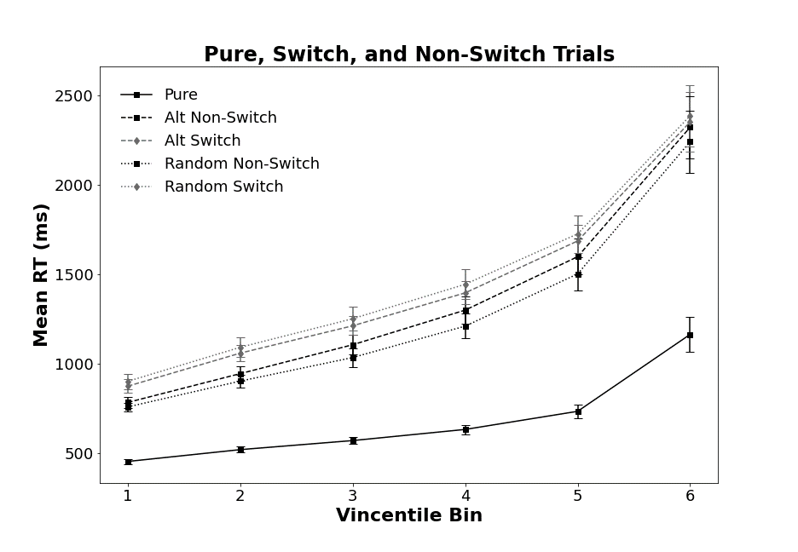

*Figure 1*. Mean RT Vincentile bin data points for pure, non-switch, and switch trials. Switch and non-switch trials are split by alternating runs and random presentation sequences. Bars denote 95% *CI*.

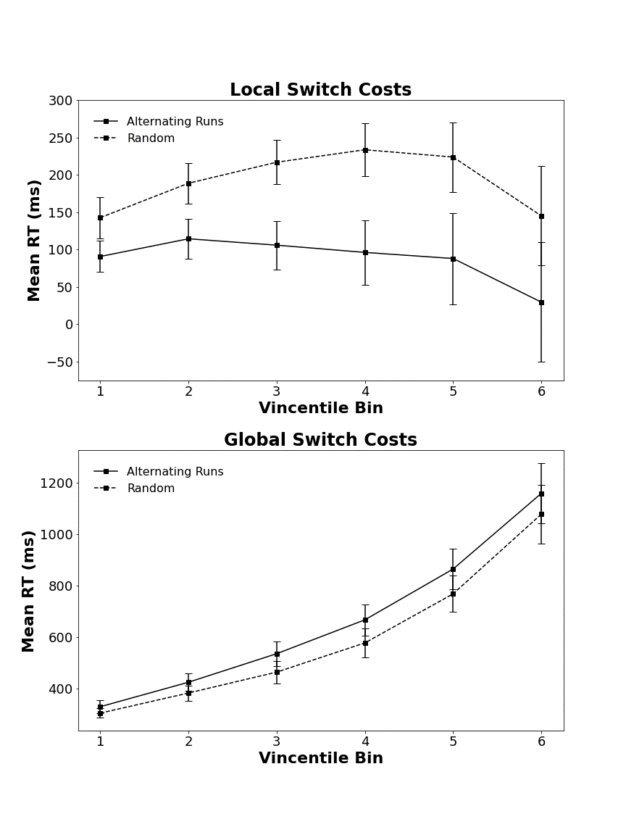

*Figure 2*. Local and global Vincentile costs for alternating runs and random switching. Bars denote 95% *CI*.